New York On-Farm Research Partnership
Project: Yield Monitor Evaluation Study 2013
Protocol and Directions-Alfalfa
This project is a collaboration between the Cornell Nutrient Management Spear Program and Agrinetix.
Questions? Contact Emmaline Long (eal93@cornell.edu) or Dave Russell (drussell@agrinetix.com)

Introduction and Objectives:
Work over the past five years has shown that great improvements can be made in nutrient use efficiency when detailed farm, feed, and field records are kept. Such progress, monitored using annual Nutrient Mass Balance (NMB) assessments, can be made while maintaining or increasing milk production, illustrating the potential for a win-win situation for farm profitability and environmental protection. To achieve the desired nutrient reductions and increased efficiencies accurate farm and field yield records are essential. Accurate yield records are the major bottleneck on many farms for diagnosing causes of high nutrient balances, identifying solutions, designing rotations that feed the cows in a sustainable way, and confidently managing nutrients on a field by field basis. Because home-grown forage and grain production impact all aspects of the farm (economics, nutrient use, environmental footprint, etc.), without accurate yield records, it is nearly impossible to systematically measure progress at the field level, much less identify where the largest nutrient use efficiency gains can be made. Accurate yield records are needed, not just to evaluate the Cornell yield potential database, but also to help farms to quicker achieve nutrient reductions.
We are looking to partner with farms with an interest in collecting calibration data for forage monitors, and share yield data to generate a statewide database (as part of our Yield Database Project) to evaluate the accuracy of yield monitoring equipment.

Scope of Work:
- Print “Yield Monitor Data Sheet” from the NMSP On-Farm Research Project Website:
  - http://nmsp.cals.cornell.edu/NYOnFarmResearchPartnership/index.html
  - Sheet has been set up to be 1 page when front-back printed
- Circle the cutting (1st, 2nd, 3rd, etc.) that the data sheet is being used for
- Fill out Farm Name, name of person collecting data, county the farm is located in, and check box to indicate whether a calibration has been done by a dealer in the last 12 months
- For each field harvesting indicate:
  - Field ID: Can be unique farm ID
  - Date the harvest is conducted, Time of Calibration
  - Full truck weight, Empty truck weight, Load (Full-Empty) weight: In pounds
  - Old Yield Monitor Calibration number & New Calibration Number: Number read off screen describing difference between actual weight and weight calculated by monitor (See Figure 1)
  - Average moisture of calibration load: % (See Figure 2)
  - Average moisture of whole field: In % (See Figure 2)
    - This is recorded because if the moisture of the field is much different than the moisture of the calibration, the values will be less accurate
    - If you do not have a moisture meter, please write the moisture number that you are calibrating on
  - Circle fraction of alfalfa in stand (closest estimate)
- Calibrations should be conducted once a day or when the moisture of the crop changes by 5 or more points, but no more than one calibration per field.
- During harvest, please make any additional notes that might be relevant to data collection and analysis
  - i.e. pest damage levels, any noticeable nutrient deficiencies, row skips, harvest at abnormal stand height, etc.
- Email or mail the completed data sheets as soon as possible after harvest to:
Emmaline Long, eal93@cornell.edu, 585-813-7228 (cell)
323 Morrison Hall, Ithaca, NY 14853

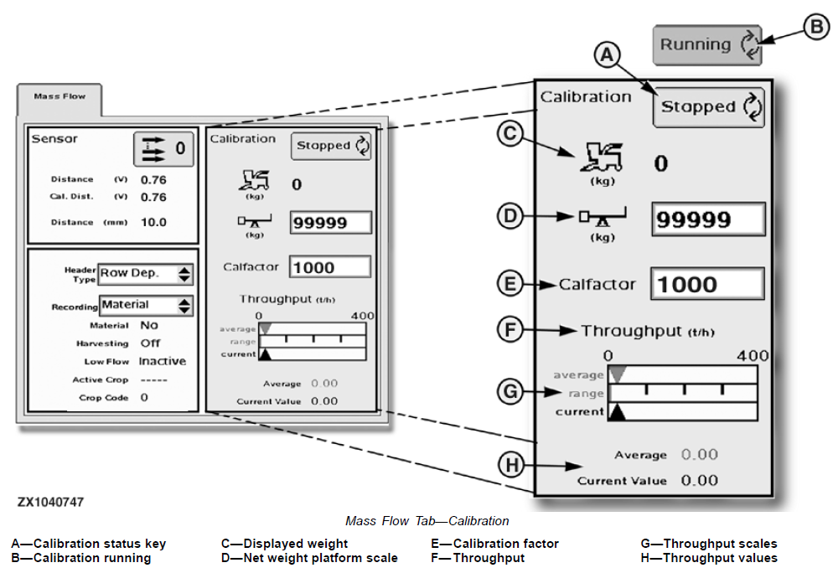
Figure 1. “Yield monitor calibration number” to be recorded on data sheet is E. Calfactor, shown on monitor screen above in the mass flow tab. This number will change once you put the new load weight in D.

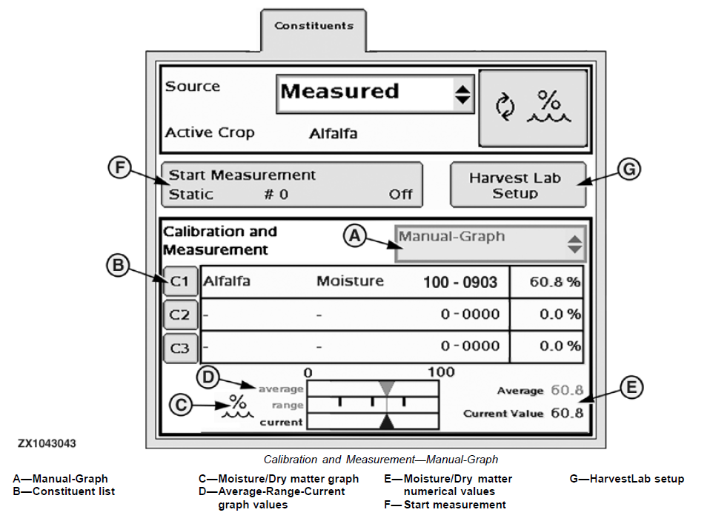
B
A
Figure 2: While in the constituents tab, “Avg. Moisture of calibration load” to be recorded on data sheet is shown by Arrow A, and “Avg. Moisture of field” is shown by Arrow B. These numbers represent just one place of several where the moisture numbers are available on the monitor. Place to find the moisture will differ depending on how the operator has the monitor configured.

Yield Monitor Study 2013
Data Sheet for Alfalfa Harvest
Circle Cutting: First Second Third Fourth Fifth

This project is a collaboration between the Cornell Nutrient Management Spear Program and Agrinetix.
Questions? Contact Emmaline Long (eal93@cornell.edu) or Dave Russell (drussell@agrinetix.com)
Please return completed data sheet to Emmaline Long, 323 Morrison Hall, Cornell University, Ithaca, 14853

Farm Name: ___________________________________________ Has a calibration by a dealer been done in the last 12 months? ☐Yes ☐No
Person collecting data:_____________________________ County:____________________________________________
Information from calibration:
Field ID | Date | Time of Calibration | Full Truck Weight | Empty Truck Weight | Load Weight (Full- Empty) | Old Yield Monitor Calibration Number | New Yield Monitor Calibration Number | Avg. Moisture of Calibration Load | Avg. Moisture of the Field | % Alfalfa in Stand
 |  |  | lbs | lbs | lbs |  |  | % | % | Circle Approx.
 | ____/____/2013 | _____:______ |  |  |  |  |  |  |  | <⅓ ⅓-⅔  >⅔
 | ____/____/2013 | _____:______ |  |  |  |  |  |  |  | <⅓ ⅓-⅔  >⅔
 | ____/____/2013 | _____:______ |  |  |  |  |  |  |  | <⅓ ⅓-⅔  >⅔
 | ___/____/2013 | _____:______ |  |  |  |  |  |  |  | <⅓ ⅓-⅔  >⅔
 | ____/____/2013 | _____:______ |  |  |  |  |  |  |  | <⅓ ⅓-⅔  >⅔
 | ____/____/2013 | _____:______ |  |  |  |  |  |  |  | <⅓ ⅓-⅔  >⅔
 | ____/____/2013 | _____:______ |  |  |  |  |  |  |  | <⅓ ⅓-⅔  >⅔
 | ____/____/2013 | _____:______ |  |  |  |  |  |  |  | <⅓ ⅓-⅔  >⅔

Field ID | Date | Time of Calibration | Full Truck Weight | Empty Truck Weight | Load Weight (Full- Empty) | Old Yield Monitor Calibration Number | New Yield Monitor Calibration Number | Avg. Moisture of Calibration Load | Avg. Moisture of the Field | % Alfalfa in Stand
 |  |  | lbs | lbs | lbs |  |  | % | %
 | ____/____/2013 | _____:______ |  |  |  |  |  |  |  | <⅓ ⅓-⅔  >⅔
 | ____/____/2013 | _____:______ |  |  |  |  |  |  |  | <⅓ ⅓-⅔  >⅔
 | ____/____/2013 | _____:______ |  |  |  |  |  |  |  | <⅓ ⅓-⅔  >⅔
 | ____/____/2013 | _____:______ |  |  |  |  |  |  |  | <⅓ ⅓-⅔  >⅔
 | ____/____/2013 | _____:______ |  |  |  |  |  |  |  | <⅓ ⅓-⅔  >⅔
 | ____/____/2013 | _____:______ |  |  |  |  |  |  |  | <⅓ ⅓-⅔  >⅔
 | ____/____/2013 | _____:______ |  |  |  |  |  |  |  | <⅓ ⅓-⅔  >⅔
 | ____/____/2013 | _____:______ |  |  |  |  |  |  |  | <⅓ ⅓-⅔  >⅔
 | ____/____/2013 | _____:______ |  |  |  |  |  |  |  | <⅓ ⅓-⅔  >⅔

Additional Notes:

